INTRODUCTION

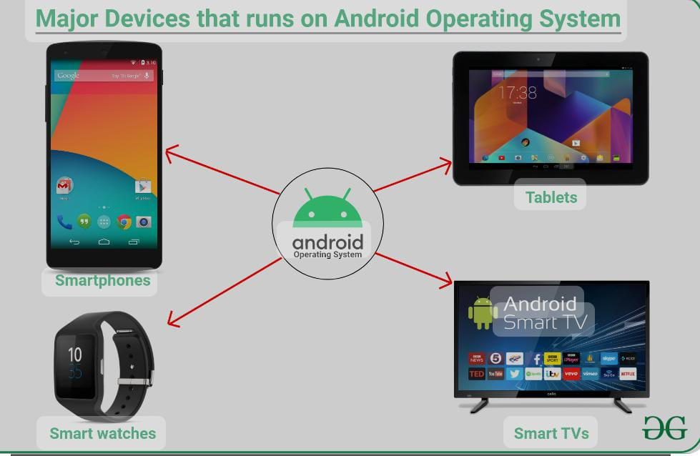

Android Inc was founded in Palo Alto, California. Rich Miner, Nick Sears, Chris White, and Andy Rubin were its four founders

Android OS is a Linux-based mobile operating system that primarily runs on smartphones and tablets.

The first commercial version, Android 1.0, was released on September 23, 2008.

The operating system is developed by Google on a yearly cycle since at least 2011. New major releases are announced at Google I/O along with its first public beta to supported Google Pixel devices.

Android operating system is the largest installed base among various mobile platforms across the globe. Hundreds of millions of mobile devices are powered by Android in more than 190 countries of the world. It conquered around 71% of the global market share by the end of 2021, and this trend is growing bigger every other day. The company named Open Handset Alliance developed Android for the first time that is based on the modified version of the Linux kernel and other open-source software.

The Android operating system was developed by Google (GOOGL​) for use in all of its touchscreen devices, tablets, and cell phones.

This operating system was first developed by Android Inc., a software company located in Silicon Valley before it was acquired by Google in 2005.

While the Android source code is released in an open-source format to help advance open standards across mobile devices, it is still packaged with proprietary software when sold on handset devices.

The Android operating system was first developed by Android Inc., a software company located in Silicon Valley before Google acquired it in 2005. Investors and electronics industry analysts have questioned Google’s true intentions for entering the mobile market space since that acquisition. But in any case, soon thereafter, Google announced the impending rollout of its first commercially available Android-powered device in 2007, although that product actually hit the marketplace in 2008.

ADVANTAGES

1. Advantages Of the Android Operating System
2. Open Ecosystem. The Android OS gives you a lot of choices for installing your favorite apps. ...
3. Open Source Operating System. ...
4. Diverse Phone Options. ...
5. Customized or Modified Rom. ...
6. User-Friendly Play Store. ...
7. Easy & Affordable App Development. ...
8. Widgets. ...
9. Expandable Storage Option.
10. Open Source Operating System

Open Source Operating System is one of the biggest advantages of Android OS. The source code is open to all, developers and device manufacturers. So they can access the source code and make changes as per their hardware compatibility.

1. Open Ecosystem

The Android OS gives you a lot of choices for installing your favorite apps. Android comes inbuilt with Google Play Store. It is the official store for downloading apps from Google. But you also have the option to download your favorite apps from any third-party app store as well.

1. Diverse Phone Options

Android is unlike Apple, where the IOS operating system is only limited to iPhone users. Android is available as an operating system in different phones and manufacturers. It means you can choose your favorite mobile based on your manufacturer brand preference and you get Android installed in it.

1. Customized or Modified Rom

Are you tired of using your stock Android and want to have some new and exciting features? You can easily install any custom ROM and enhance your user experience. Several third-party applications help you in using the advanced features of Android by using a custom ROM. It is an extremely useful feature because it lets you change the stock Android all over.

1. User-Friendly Play Store

BothGoogle Playstore and Apple-store have more than 1 million applications to download. Users can download apps as per their requirements. But Google play store is much easier to operate and user-friendly as compared to Apple’s App Store.

1. Easy & Affordable App Development

App development is extremely easy and affordable when it comes to Android. You can develop your app and list it on the play store without the need to pay any large development fees.

1. Widgets

One of the useful advantages of Android OS is Widgets. Widgets, or self-contained programs, are extremely useful when it comes to functionality. A Widget helps to provide a better user experience and easy navigational functions.

1. Expandable Storage Option

To increase the storage capacity of any Apple device you need to go for a costly upgrade and a lot of hassle. But in the case of Android devices, you can insert a micro SD memory card into your device card slot. It will expand the memory as per your need.

Drawbacks of Android Operating System:

1. .Apps Remain Active In The Background. ...
2. Developers Are Having A Rough Time. ...
3. Low Specification Smartphones Run Slowly. ...
4. Defense From Viruses. ...
5. Many Advertisements In Apps. ...
6. Not Helpful To Aged Persons. ...
7. Google Account Needed. ...
8. Bad Content Of Software.
9. The concept of a new application is complicated
10. Google is strict for software developers.
11. Software update.

1.Apps Remain Active In The Background

In the earlier system of Android, many applications still operate in the background but also move to the forefront as they would like. But the latest edition of Android applications cannot immediately come to the fore. When specific applications operate in the background, they drain a cell battery, and the phone’s power disappears quickly.

2.Developers Are Having A Rough Time

Training and designing Android applications is challenging since there are many display sizes and making the software adaptive to these display sizes is difficult for designers.

3.Low Specification Smartphones Run Slowly

Android is an extensive operating system that uses many resources, and some standard applications even come with the operating system. Therefore lower specification smartphones run slowly. Whenever you load many applications on these machines, your cell phone can become reactive or overheat quickly

4. Defense From Viruses

Android isn’t effective at protecting the infection. Users can import and install software from other foreign sites, and such applications might contain viruses and could have stolen the files and records. This is also found that some of the games in the play store carry a virus.

5. Many Advertisements In Apps

Several Android applications are available for free download; however, they arrive with plenty of advertisements that appear on the application screens or ads while you operate some function in the application. This is annoying to the user, and the user needs to purchase a software authorization to delete advertisements or disable an app.

6. Not Helpful To Aged Persons

Old users have a hard time utilizing Android smartphones due to sophisticated touch displays. They might have had an issue with their vision and who haven’t used smartphone Android earlier.

7. Google Account Needed

You require a Gmail profile to install applications via the play store. You will require a Gmail profile to use few Google apps as well. Whether you lose the Gmail Address, your smartphone will be encrypted, and you have to find your Gmail address to activate it.

8. Bad Content Of Software

Most applications throughout the app store are of low quality, and certain apps try to make money by showing advertisements and have little need for consumers. Any applications have not been upgraded for several years, which will impact people who are updating their software.

9. The Concept Of A New Application Is Complicated

There are fewer opportunities for developers to render apps that aren’t yet accessible. When all kinds of software are already available within the app store, it’s hard for new businesses and entrepreneurs to reach the Android industry. But the developer is still able to build a secure trading bitcoin evolution to help you in your business.

10. Google Is Strict For Software Developers

When Google detects some issues with your software, it would be very permissive and might cancel your developer profile.

11. Software Update

The software update is one of the disadvantages of the android phone. If you are running an old android smartphone, then you cannot update your smartphone to a newer version of Android. There are a bunch of smartphones accessible in the market with the older android versions. If you want to enjoy the latest version of Android, then you have to buy the new flagships of the android smartphone.